Creating Custom Reports to compare Pre and Post-tests.

- Log onto SchoolCity (https://stars.schoolcity.com/prod23/sc/logon?isn=granite)
- Go to Reports
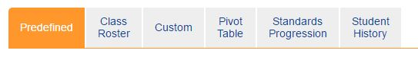
  - Custom

- In the top right corner, you will see “Create New”. Click on this.

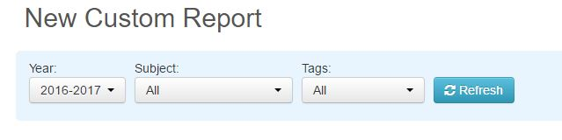
- Make sure the year is correct and then choose your subject; and hit refresh.

- You should now see all of the tests associated with the course subject.

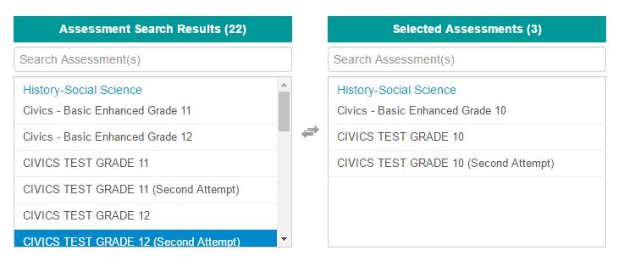
- Find the tests you want to compare and double click on them. They will move from the Assessment Search Results window to the Selected Assessments window. You can have multiple tests to compare.

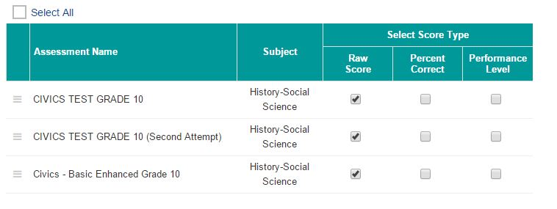
- As you add assessments to the “Selected” window, you will see them come up at the bottom of the page. You then need to choose what type of information you would like to see. (You may also, “Select All”.)

- At the bottom, click “Save & Run Report”.

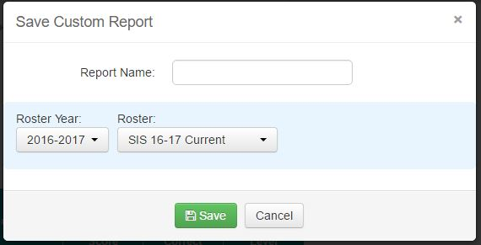
- When giving your report a name, please include your initials. This allows administrative users to see what reports are created and by whom. Click “Save”.

- Your report will then run and you should be able to see the data that you chose.

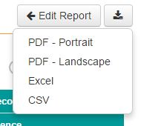
- From here, you can download the report into a PDF, Excel, or CSV file for review and/or printing.

